Australians
in
Conflict

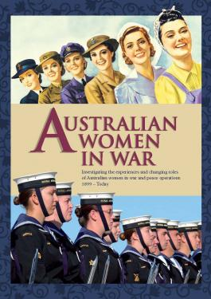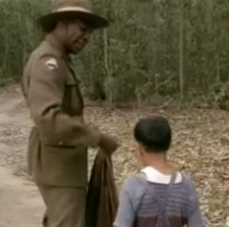
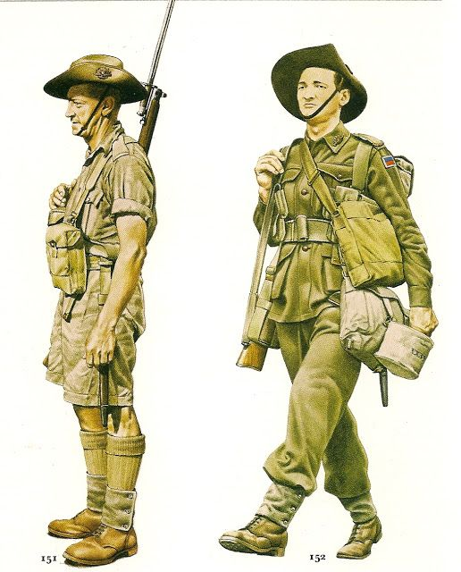

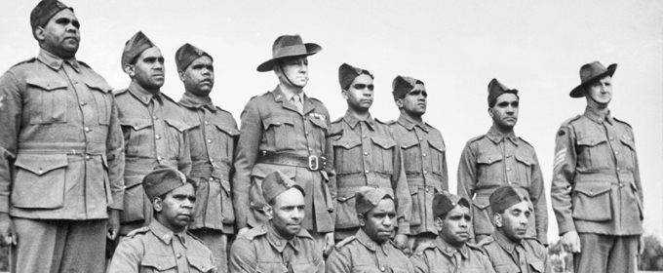
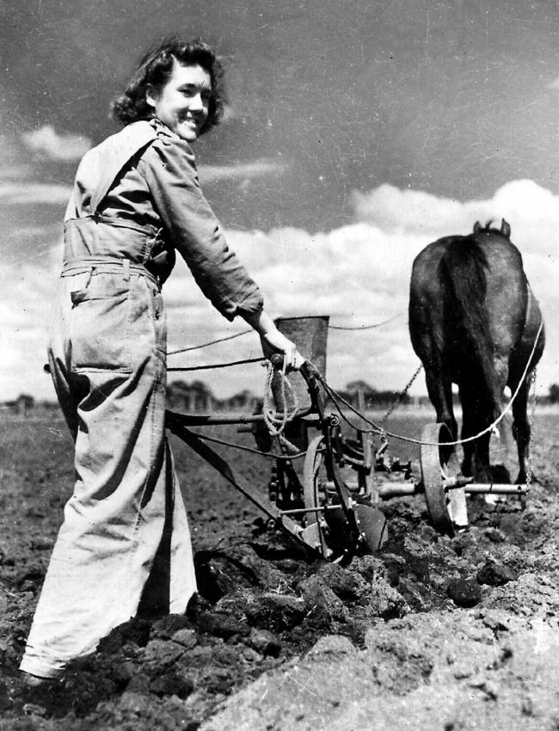

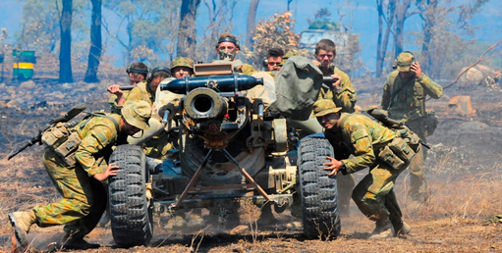
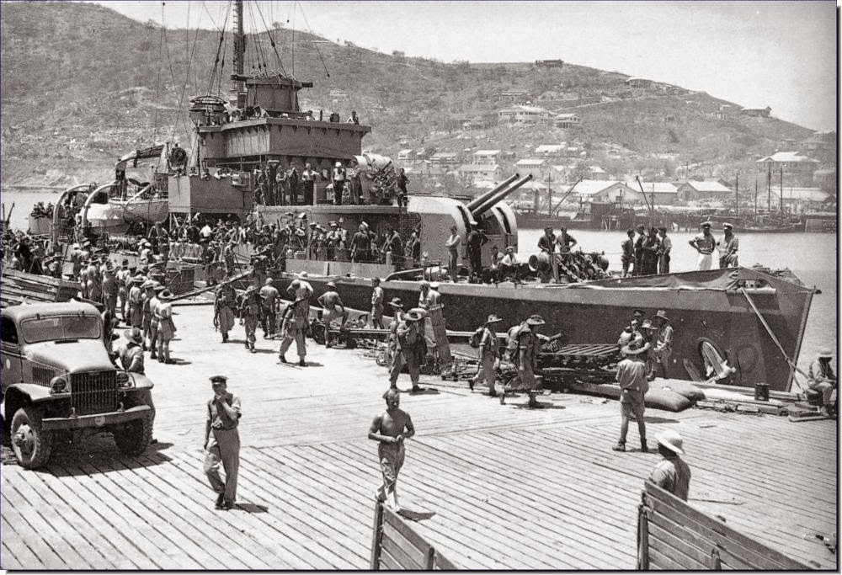

NAME: ____________________________________
Australians in Conflict
In this unit, we will be reading and viewing texts that explore Australia’s involvement in conflict. The focus of our study will be on alternative views and perspectives. As we examine each text, we will discover that some perspectives are privileged while others are marginalised or silenced.

Before we begin the unit, let’s define a few key terms using the syllabus glossary or a dictionary.

Perspective
A perspective is a position from which things may be viewed or considered. People may have different perspectives or views on events or issues due to (for example) their age, gender, social position and beliefs and values. A perspective is more than an opinion; it is a viewpoint informed by one or more contexts. Texts, through an embedded (this means implied or not immediately obvious) belief system (or ideology), can also present a particular perspective or be read from an ideological (or belief system) perspective.

Representation
A representation is the way people, events, issues or subjects are presented in a text. The term implies that texts are not mirrors of the real world; they are constructions (or images) of reality. These constructions are partially shaped through the writer’s use of conventions and techniques. In the case of the three little pigs, the pig who built the brick house is represented as being the cleverest brother as his house could not be destroyed by the wolf.

Privilege
If a person, or a group or a concept is privileged, then they are given a special advantage or right that is not available to others. If a concept or an idea is privileged (this is the verb form of the noun, privilege), this means it is foregrounded or emphasised to such an extent that it stands out and becomes the dominant interpretation. Other ideas or concepts are harder to recognise or don’t receive as much attention (or screen/air time) because they are not considered to be as important as the privileged version.

In other words, if something is stressed and brought to our attention first, then it is privileged. For example, we only know about the three little pig’s side of the story; we don’t know the wolf’s perspective.

Marginalisation and Silencing
Marginalisation is the treatment of a person, a group, or a concept as insignificant or peripheral (on the edge). This means that the person, group or concept is considered unimportant or is sidelined. If you sideline someone socially - sometimes this is also called social exclusion - you send them to the fringes of society. People who don’t fit in because they are marginalised, can then miss out on opportunities that others have. In a social situation, the person marginalised might not get to go to parties because they don’t know the party is on or they may not hear about a local job opportunity because no one speaks to them about it. This means their future prospects are limited because they are not included or given the knowledge they need to be successful. In the three little pig’s story, the wolf’s perspective is marginalised because we do not know what he was thinking or why he did what he did.

Silencing occurs when a particular perspective is marginalised so much that it is not even included in the text. Little Red Riding Hood’s grandmother is a silenced character because her perspective is not included in the fairy tale.
Activity 1: Before you read any of the texts that follow, take some time to consider the following
questions:
1. Why do we privilege men’s perspectives on war but marginalise women’s?
______________________________________________________________________________
______________________________________________________________________________
______________________________________________________________________________
______________________________________________________________________________
______________________________________________________________________________
______________________________________________________________________________
______________________________________________________________________________
______________________________________________________________________________
______________________________________________________________________________
______________________________________________________________________________
______________________________________________________________________________
______________________________________________________________________________
______________________________________________________________________________
______________________________________________________________________________
2. Why are Indigenous stories silenced? ______________________________________________
______________________________________________________________________________
______________________________________________________________________________
______________________________________________________________________________
______________________________________________________________________________
______________________________________________________________________________
______________________________________________________________________________
______________________________________________________________________________
______________________________________________________________________________
______________________________________________________________________________
______________________________________________________________________________
______________________________________________________________________________
______________________________________________________________________________
______________________________________________________________________________
______________________________________________________________________________
3. Why are European conflicts privileged and Australian and Asian conflicts marginalised?
______________________________________________________________________________
______________________________________________________________________________
______________________________________________________________________________
______________________________________________________________________________
______________________________________________________________________________
______________________________________________________________________________
______________________________________________________________________________
______________________________________________________________________________
______________________________________________________________________________
______________________________________________________________________________
______________________________________________________________________________
______________________________________________________________________________
______________________________________________________________________________
______________________________________________________________________________
______________________________________________________________________________
4. Why were some Australian soldiers welcomed home while others weren’t?
______________________________________________________________________________
______________________________________________________________________________
______________________________________________________________________________
______________________________________________________________________________
______________________________________________________________________________
______________________________________________________________________________
______________________________________________________________________________
______________________________________________________________________________
______________________________________________________________________________
______________________________________________________________________________
______________________________________________________________________________
______________________________________________________________________________
______________________________________________________________________________
______________________________________________________________________________
______________________________________________________________________________
Australians at War

The following information was taken from the Australian War Memorial Website. https://www.awm.gov.au/articles/atwar. Each picture represents a distinct theatre of war.

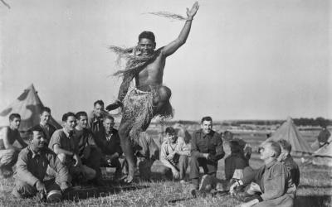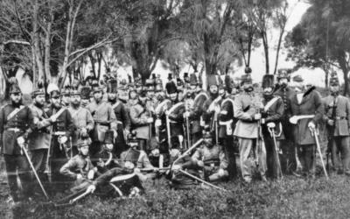
5. Indigenous service in Australia’s armed
forces in peace and war
6. Colonial period, 1788-1901

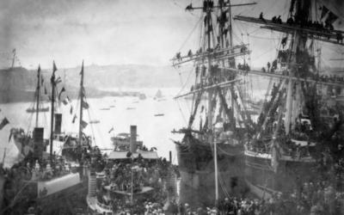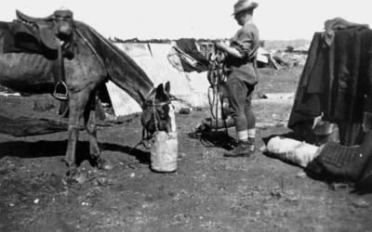
7. Sudan (NSW Contingent) March-June 1885
8. Australia and the Boer War, 1899-1902
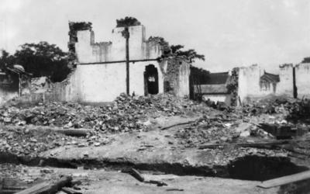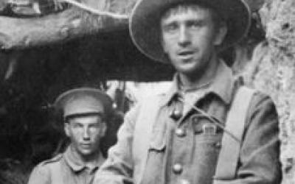
10. First World War, 1914-18
9. China (Boxer Rebellion), 1900-1901.

Australians at War

The following information was taken from the Australian War Memorial Website. https://www.awm.gov.au/articles/atwar. Each picture represents a distinct theatre of war.

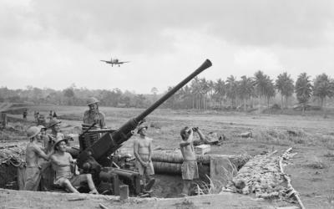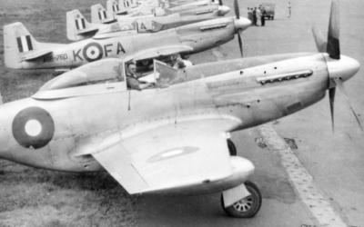
12. British Commonwealth Occupation Force, 1945-52
11. Second World War, 1939-45
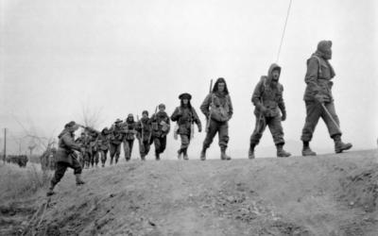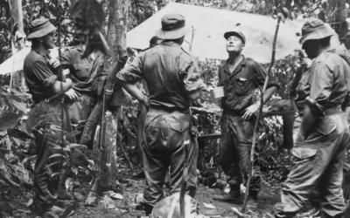
14. Malayan Emergency
13. Korean War, 1950-53
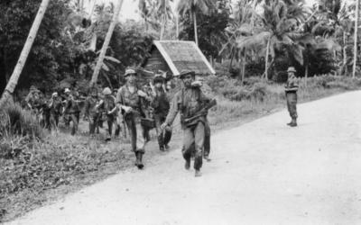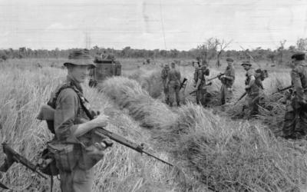
16. Vietnam War, 1962-75
15. Indonesian Confrontation, 1963-66

Australians at War

The following information was taken from the Australian War Memorial Website. https://www.awm.gov.au/articles/atwar. Each picture represents a distinct theatre of war.

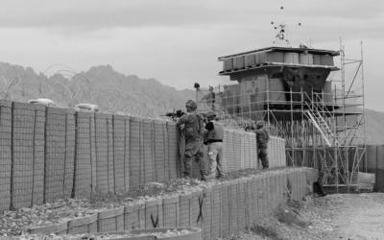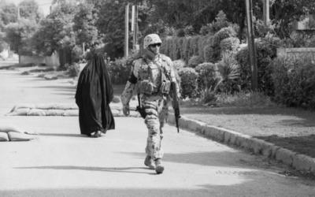
18. Iraq War, 2003-09
17. Afghanistan, 2001-present
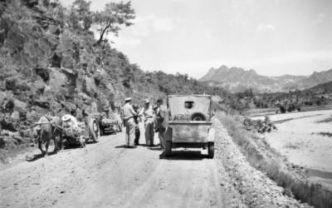
19. Australians and Peacekeeping
If you have the time and you would like to know more about the above conflicts, then use the link at the top of pages 5-7 to go to the Australian War Memorial Webpage. Once there, if you click on each picture you will be taken the section of the website that deals with that conflict. You will find that there is quite extensive information provided on each item. Did you realise that Australians have been involved in so many conflicts? Why might this be the case? Explain
______________________________________________________________________________
______________________________________________________________________________
______________________________________________________________________________
______________________________________________________________________________
______________________________________________________________________________
Activity 2: Over to You
Each of the photographs above is numbered from 5 to 19. Re-read the information on page 2 and use it to complete the following:
Identify whether each of the named conflicts has been privileged, marginalised or silenced by ticking the appropriate column in the table below.
Consider: if a conflict is well known, then perspectives concerning it have been privileged; if you are aware of its existence but don’t really know much about it, then perspectives exploring it have been marginalised; if you know very little to nothing about the conflict, then perspectives about these conflicts have been silenced.
Be prepared to explain your responses.
You will be asked to share your response and your explanation with the class.

 | Privileged | Marginalised | Silenced
5
6
7
8
9
10
11
12
13
14
15
16
17
18
19

I Was Only Nineteen
Listen to the You Tube recording of the Redgum Song, I Was Only Nineteen. It is about the experience of soldiers in the Vietnam War. https://www.youtube.com/watch?v=1gmgwx77osw
Mum and Dad and Denny saw the passing out parade at Puckapunyal alliteration -emphasis
It was a long march from cadets repetition= emphasis
The sixth battalion was the next to tour and it was me who drew the card
Pride We did Canungra and Shoalwater before we left anecdotes=personal
story
And Townsville lined the footpaths as we marched down to the quay
This clipping from the paper shows us young and strong and clean tricolon- threes
And there's me in me slouch hat with me SLR and greens visual imagery - photograh
God help me - I was only nineteen
From Vung Tau riding Chinooks to the dust at Nui Dat
I'd been in and out of choppers now for months
And we made our tents a home, V.B. and pinups on the lockers
And an Asian orange sunset through the scrub
And can you tell me, doctor, why I still can't get to sleep?
And night time's just a jungle dark and a barking M.16?
And what's this rash that comes and goes, can you tell me what it means?
God help me - I was only nineteen
A four week operation, when each step can mean your last one on two legs rhytmn breaks
Stoicism It was a war within yourself
But you wouldn't let your mates down 'til they had you dusted off
So you closed your eyes and thought about somethin' else
And then someone yelled out "Contact", another bloke swore
We hooked in there for hours, then a God almighty roar
And Frankie kicked a mine the day that mankind kicked the moon
God help me - he was goin' home in June
And I can still see Frankie, drinkin' tinnies in the Grand Hotel
On a thirty-six hour rec. leave in Vung Tau comparison Imagery
And I can still hear Frankie, lying screaming in the jungle auditory imagery
'Til the morphine came and killed the bloody row
And the Anzac legends didn't mention mud and blood and tears
Protection And the stories that my father told me never seemed quite real.
I caught some pieces in my back that I didn't even feel
God help me, I was only nineteen.

Source: Musixmatch
Songwriters: John Lewis Schumann
I Was Only 19 (A Walk in the Light Green) lyrics © Universal Music Publishing Pty. Ltd.

20. Each stanza deals with a separate issue and idea.
a) Annotate the text above to identify each issue and idea raised in the text.
b) In your own words, what is the song about?
______________________________________________________________________________
______________________________________________________________________________
______________________________________________________________________________
______________________________________________________________________________
______________________________________________________________________________
______________________________________________________________________________
______________________________________________________________________________
______________________________________________________________________________
______________________________________________________________________________
______________________________________________________________________________
______________________________________________________________________________
21. How are ideas presented in the song?

Ideas | Techniques

22. Write a TEEL paragraph identifying whose perspective is privileged in I Was Only Nineteen.
Use evidence to support your answer.
______________________________________________________________________________
______________________________________________________________________________
______________________________________________________________________________
______________________________________________________________________________
______________________________________________________________________________
______________________________________________________________________________
______________________________________________________________________________
______________________________________________________________________________
______________________________________________________________________________
______________________________________________________________________________
______________________________________________________________________________
______________________________________________________________________________
______________________________________________________________________________
______________________________________________________________________________
______________________________________________________________________________
______________________________________________________________________________
______________________________________________________________________________
______________________________________________________________________________
______________________________________________________________________________
23. Write a TEEL paragraph identifying whose perspective is marginalised in I Was Only Nineteen.
Use evidence to support your answer.
______________________________________________________________________________
______________________________________________________________________________
______________________________________________________________________________
______________________________________________________________________________
______________________________________________________________________________
______________________________________________________________________________
______________________________________________________________________________
______________________________________________________________________________
______________________________________________________________________________
______________________________________________________________________________
______________________________________________________________________________
______________________________________________________________________________
______________________________________________________________________________
______________________________________________________________________________
______________________________________________________________________________
______________________________________________________________________________
______________________________________________________________________________
______________________________________________________________________________
______________________________________________________________________________
______________________________________________________________________________
______________________________________________________________________________
______________________________________________________________________________
24. Write a TEEL paragraph identifying whose perspective is silenced in I Was Only Nineteen.
Explain your response in some detail.
______________________________________________________________________________
______________________________________________________________________________
______________________________________________________________________________
______________________________________________________________________________
______________________________________________________________________________
______________________________________________________________________________
______________________________________________________________________________
______________________________________________________________________________
______________________________________________________________________________
______________________________________________________________________________
______________________________________________________________________________
______________________________________________________________________________
______________________________________________________________________________
______________________________________________________________________________
______________________________________________________________________________
______________________________________________________________________________
______________________________________________________________________________
______________________________________________________________________________
______________________________________________________________________________
25, What attitudes are expressed about war in the song? Use evidence to support your answer.
______________________________________________________________________________
______________________________________________________________________________
______________________________________________________________________________
______________________________________________________________________________
______________________________________________________________________________
______________________________________________________________________________
______________________________________________________________________________
______________________________________________________________________________
______________________________________________________________________________
______________________________________________________________________________
______________________________________________________________________________
______________________________________________________________________________
______________________________________________________________________________
______________________________________________________________________________
______________________________________________________________________________
______________________________________________________________________________
______________________________________________________________________________
______________________________________________________________________________

Harry’s War
Use the following web address to view the visual text, Harry’s War. https://aso.gov.au/titles/shorts/harrys-war/clip1/
26. Each stanza deals with a separate issue and idea.
a) Identify each issue and idea raised in the text. In your own words, what is Harry’s
War about?
______________________________________________________________________________
______________________________________________________________________________
______________________________________________________________________________
______________________________________________________________________________
______________________________________________________________________________
______________________________________________________________________________
______________________________________________________________________________
______________________________________________________________________________
______________________________________________________________________________
______________________________________________________________________________
______________________________________________________________________________
______________________________________________________________________________
______________________________________________________________________________
______________________________________________________________________________
______________________________________________________________________________
______________________________________________________________________________
______________________________________________________________________________
______________________________________________________________________________
27. How are ideas presented in the film excerpt?
Ideas | Techniques

28. Write a TEEL paragraph identifying whose perspective is privileged in Harry’s War.
Use evidence to support your answer.
______________________________________________________________________________
______________________________________________________________________________
______________________________________________________________________________
______________________________________________________________________________
______________________________________________________________________________
______________________________________________________________________________
______________________________________________________________________________
______________________________________________________________________________
______________________________________________________________________________
______________________________________________________________________________
______________________________________________________________________________
______________________________________________________________________________
______________________________________________________________________________
______________________________________________________________________________
______________________________________________________________________________
______________________________________________________________________________
______________________________________________________________________________
______________________________________________________________________________
______________________________________________________________________________
29. Write a TEEL paragraph identifying whose perspective is marginalised in Harry’s War.
Use evidence to support your answer.
______________________________________________________________________________
______________________________________________________________________________
______________________________________________________________________________
______________________________________________________________________________
______________________________________________________________________________
______________________________________________________________________________
______________________________________________________________________________
______________________________________________________________________________
______________________________________________________________________________
______________________________________________________________________________
______________________________________________________________________________
______________________________________________________________________________
______________________________________________________________________________
______________________________________________________________________________
______________________________________________________________________________
______________________________________________________________________________
______________________________________________________________________________
______________________________________________________________________________
______________________________________________________________________________
______________________________________________________________________________
______________________________________________________________________________
______________________________________________________________________________
30. Write a TEEL paragraph identifying whose perspective is silenced in Harry’s War.
Explain your response in some detail.
______________________________________________________________________________
______________________________________________________________________________
______________________________________________________________________________
______________________________________________________________________________
______________________________________________________________________________
______________________________________________________________________________
______________________________________________________________________________
______________________________________________________________________________
______________________________________________________________________________
______________________________________________________________________________
______________________________________________________________________________
______________________________________________________________________________
______________________________________________________________________________
______________________________________________________________________________
______________________________________________________________________________
______________________________________________________________________________
______________________________________________________________________________
______________________________________________________________________________
______________________________________________________________________________
31. What attitudes are expressed about war in the film excerpt? Use evidence to support your answer.
______________________________________________________________________________
______________________________________________________________________________
______________________________________________________________________________
______________________________________________________________________________
______________________________________________________________________________
______________________________________________________________________________
______________________________________________________________________________
______________________________________________________________________________
______________________________________________________________________________
______________________________________________________________________________
______________________________________________________________________________
______________________________________________________________________________
______________________________________________________________________________
______________________________________________________________________________
______________________________________________________________________________
______________________________________________________________________________
______________________________________________________________________________
______________________________________________________________________________
______________________________________________________________________________
______________________________________________________________________________
______________________________________________________________________________
______________________________________________________________________________
______________________________________________________________________________
______________________________________________________________________________
______________________________________________________________________________
______________________________________________________________________________
______________________________________________________________________________
______________________________________________________________________________
______________________________________________________________________________
______________________________________________________________________________
______________________________________________________________________________
______________________________________________________________________________
______________________________________________________________________________
______________________________________________________________________________
______________________________________________________________________________
______________________________________________________________________________
______________________________________________________________________________
______________________________________________________________________________
______________________________________________________________________________
______________________________________________________________________________
______________________________________________________________________________
______________________________________________________________________________
______________________________________________________________________________
PLANNING FOR ASSESSMENT: Reflection in Response to a Prompt
Explore how some perspectives are privileged, as well as some beliefs, attitudes and values, while others are marginalised or silenced, in at least one reading and viewing text you have studied this year.
Text:

Author/Director:

Perspective/s privileged:

Perspective/s marginalised:

Perspectives silenced:

Attitudes privileged:

Attitudes marginalised:

Attitudes silenced:

Values privileged:

Values marginalised:

Values silenced:

Beliefs privileged:

Beliefs marginalised:

Beliefs silenced:

What will you select to discuss?
Perspectives = compulsory
Prompt says to discuss some beliefs, attitudes, values.
In my assessment I will talk about:
1. Perspective/s:
2. Beliefs?
3. Values?
4. Attitudes?

Australians at war
The following information was taken from the Australian War Memorial Website. https://www.awm.gov.au/articles/atwar
These short chapters cover Australia's involvement in war, from the time of the first settlement at Sydney Cove in the 18th century to our peacekeeping roles under United Nations auspices and the First and Second Gulf Wars. This material has been prepared by the Memorial's Military History Section.

Text 1: Australian troops in the Turkish Lone Pine trenches,

captured on the afternoon of the 6 August ...
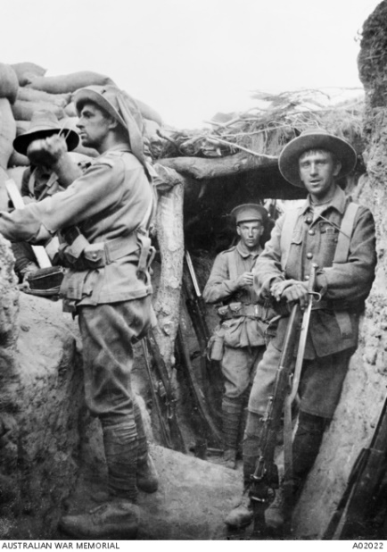
Australian troops in the Turkish Lone Pine trenches, captured on the afternoon of the 6 August 1915, by the AIF 1st Brigade under Brigadier-General Walker. The soldier at centre back is probably 2125 Private (Pte) Joseph Clark, 7th Battalion, of South Yarra, Victoria (Originally of Maldon, Victoria). Clark, an 18 year old bootmaker, enlisted on 22 April 1915 with his 21 year old brother 2124 Robert Clark. The brothers returned to Australia in May 1916 after being wounded. A third brother, 10/1208 Pte Percival Clark, also served at Gallipoli with the Wellington Infantry Battalion and survived the war.

Summary
Australia’s involvement in the First World War began when Britain and Germany went to war on 4 August 1914, and both Prime Minister Joseph Cook and Opposition Leader Andrew Fisher, who were in the midst of an election campaign, pledged full support for Britain. The outbreak of war was greeted in Australia, as in many other places, with great enthusiasm.
The first significant Australian action of the war was the Australian Naval and Military Expeditionary Force’s (ANMEF) landing on Rabaul on 11 September 1914. The ANMEF took possession of German New Guinea at Toma on 17 September 1914 and of the neighbouring islands of the Bismarck Archipelago in October 1914. On 9 November 1914 the Royal Australian Navy made a major contribution when HMAS Sydney destroyed the German raider SMS Emden.
On 25 April 1915 members of the Australian Imperial Force (AIF) landed on Gallipoli in Turkey with troops from New Zealand, Britain, and France. This began a campaign that ended with an evacuation of allied troops beginning in December 1915. The next year Australian forces fought campaigns on the Western Front and in the Middle East.
Throughout 1916 and 1917 losses on the Western Front were heavy and gains were small. In 1918 the Australians reached the peak of their fighting performance in the battle of Hamel on 4 July. From 8 August they then took part in a series of decisive advances until they were relieved in early October. Germany surrendered on 11 November.
The Middle East campaign began in 1916 with Australian troops taking part in the defence of the Suez Canal and the allied re-conquest of the Sinai Desert. In the following year Australian and other allied troops advanced into Palestine and captured Gaza and Jerusalem; by 1918 they had occupied Lebanon and Syria and on 30 October 1918 Turkey sued for peace.
For Australia, the First World War remains the costliest conflict in terms of deaths and casualties. From a population of fewer than five million, 416,809 men enlisted, of whom more than 60,000 were killed and 156,000 wounded, gassed, or taken prisoner.
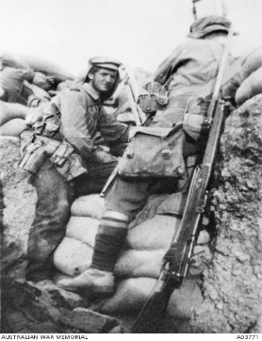

History
When Britain declared war against Germany in August 1914, Australia, as a dominion of the British Empire, was automatically also at war. While thousands rushed to volunteer, most of the men accepted into the Australian Imperial Force in August 1914 were sent first to Egypt, not Europe, to meet the threat which a new belligerent, the Ottoman Empire, posed to British interests in the Middle East and the Suez Canal.

After four and a half months of training near Cairo, the Australians departed by ship for the Gallipoli peninsula, along with troops from New Zealand, Britain, and France. On 25 April 1915 the Australians landed at what became known as Anzac Cove, whereupon they established a tenuous foothold on the steep slopes above the beach. During the early days of the campaign the allies tried to break through Turkish lines, while the Turks tried to drive the allied troops off the peninsula. Attempts on both sides ended in failure and the ensuing stalemate continued for the remainder of 1915. In fact, the most successful operation of the campaign was the large-scale evacuation of troops on 19 and 20 December. As a result of a carefully planned deception operation, the Turks were unable to inflict more than a very few casualties on the withdrawing forces.
After Gallipoli the AIF was reorganised and expanded from two to five infantry divisions, all of which were progressively transferred to France, beginning in March 1916. The light horse regiments that had served as additional infantry during the Gallipoli campaign remained in the Middle East. By the time the other AIF divisions arrived in France, the war on the Western Front had long been in a stalemate, with the opposing armies facing each other from trench systems that extended across Belgium and north-east France, all the way from the English Channel to the Swiss border. The development of machine-guns and artillery favoured defensive over offensive operations, and this compounded the impasse that lasted until the final months of the war.
While the fighting continued throughout 1916 and 1917, the Australians and other allied armies repeatedly attacked the German trenches, preceded by massive artillery bombardments intended to cut barbed wire and destroy defences. After these bombardments, waves of attacking infantry would emerge from the trenches into no man’s land and advance towards the enemy positions. The surviving Germans, protected by deep and heavily reinforced bunkers, were usually able to repel the attackers with machine-gun fire and artillery support from the rear. These attacks often resulted in limited territorial gains followed, in turn, by German counter-attacks. Although this style of warfare favoured the defensive armies, both sides sustained heavy losses.
In July 1916 Australian troops were introduced to this type of combat at Fromelles, where they suffered 5,533 casualties in 24 hours. By the end of the year about 40,000 Australians had been killed or wounded on the Western Front. In 1917 a further 76,836 Australians became casualties in battles such Bullecourt, Messines, and the four-month campaign around Ypres known as the battle of Passchendaele.
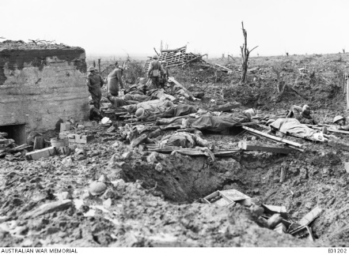
Australian infantry wounded at a First Aid Post near Zonnebeke Railway Station.
In March 1918 the German army launched a massive Spring Offensive, hoping for a decisive victory before the industrial strength of the United States could be fully mobilised in support of the allies. The Germans initially met with great success, advancing 64 kilometres past the Somme battlefields of 1916, but eventually lost momentum. Between April and November the stalemate of the preceding years began to give way. When the German offensive failed, the allied armies began their own counter-offensive combining infantry, artillery, tanks, and aircraft to great effect, demonstrated in the Australian capture of Hamel on 4 July 1918. Beginning on 8 August, this offensive contributed to further Australian successes at Mont St Quentin and Péronne and to the capture of the Hindenburg Line. In early October, after the fighting at Montbrehain, the Australian divisions withdrew from the front for rest and refitting; they were preparing to return to the fighting when Germany signed the Armistice on 11 November.
